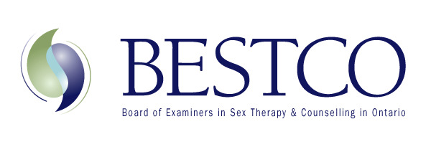 Registrar: Michelle Fischler MSW, RSW, RP registrar@bestco.info

Dear Colleague,
We are so pleased that you are interested in joining BESTCO.

Being a BESTCO member connects you with other therapists dedicated to offering services related to sex therapy and sexual health for individuals and those in relationships. BESTCO is the only organization in Ontario that offers the designation of Certified Sex Therapist. It also offers a public-accessible directory listing and a listserv/forum to connect with your BESTCO colleagues.

BESTCO is dedicated to advancing excellence in the field of sex therapy in Ontario; identifies to the public, clinicians who have training in sex therapy; sets and upholds standards for granting certified status in sex therapy, evaluates candidates towards certification; and, provides bi-annual continuing education for BESTCO members and guests.

Once your completed application package is received, including the fillable application form on the website in addition to the documents listed on this fillable form under SECTION 7 that are required to be emailed to the Registrar, your application will be reviewed by the Documentation Committee. This committee meets 4 times per year. You will be informed by the Registrar about when the next Documentation Committee meeting is scheduled. Once accepted as an Associate Member you will be informed via email by the Chair of the Documentation Committee. The Chair will welcome you and let you know of the steps required to attain full Registered Membership, including supervising requirements.

You will note in the application that beyond having a master degree, there are two required courses: one graduate level intensive sexuality course ( Minimum of 35 hours) and the Sexual Attitudes Reassessment (SAR) (Minimum of 14 hours). These are NOT required prior to applying to BESTCO as an associate. Once you are an associate member you will have 3 years to complete these course requirements. The same time frame applies to completion of your relationship and sex therapy supervision hours.

Once your fully completed application has been received by the Registrar, your application will be reviewed by the Documentation Committee. This committee meets 4 times per year on:

April 5th, 2023
June 19th, 2023
September 25th, 2023
December 4th, 2023

Your application must be received no later than 2 weeks prior to the next meeting date for it to be reviewed.

Once approved as an associate member, you will be informed via email by the Chair of the Documentation Committee. They will welcome you and let you know of the steps required to attain full certified membership, including the required number of supervision and direct client therapy hours.

On your attainment of associate status, you will be added to the website. This will allow you to access the “members only” section. There you will have access to the forum and to dates for upcoming bi-annual BESTCO meetings. You will see these meetings advertised on our website under “Upcoming Events”. These meetings typically fall on a Thursday and Friday. Thursday is the Education Module that we encourage all associates and certified members to attend. Non- BESTCO clinicians, educators and medical professionals in the community are also welcome, so if you haven’t heard back from us about your application status you are still welcome and encouraged to register to the meeting. The only portion of the meeting that is for associates, certified members and affiliate members is the business meeting and that generally happens on the Friday morning.

If you have questions at any point in this process, please do not hesitate to email me at

registrar@bestco.info

Again, thank you for your interest in BESTCO. Sincerely,

Michelle Fischler MSW, RSW, RP, BESTCO Registrar

​​​​

